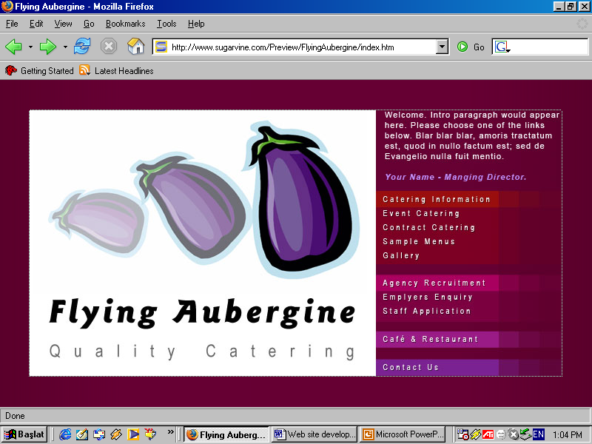

Terms and Conditions of Event Equipment Hire

- These Terms and Conditions are between Flying Aubergine Ltd, Event Equipment Hire hereinafter called “The Company”, the hirer hiring the Equipment hereinafter called “The Hirer” and the goods subject to this contract and specified in the order for hereinafter called “ The goods”.

- The contract becomes binding when “The Company” have confirmed the order to you “The Hirer” either verbally or in writing as appropriate. The Company reserve the right to revise or withdraw any quotation prior to acceptance and all quotes are subject to equipment being available at time of booking. The Company reserves the right to amend the delivery/collection charges in line with any fuel increases, or an increase in LPG prices.

- The Company does not accept responsibility for public liability.

- All equipment hired remains the property of the Company.

- The hire period is for the standard hire of 3 days unless stated otherwise by the Company. Delivery the 1st day, use the 2nd day and collect the 3rd day. In the case of weekends we deliver on a Friday and collect on a Monday. The hirer may not extend the hire period without prior permission from the Company and the hirer will be charged accordingly.

- The hirer warrants that the person signing the delivery note is duly authorized to sign on behalf of the hirer. The person who signs the delivery note will be given reasonable time to inspect the hired equipment and confirm the equipment received is correct and in good condition. The delivery note will list all hired items including the containers in which the items are delivered. Should the hirer have any cause for complaint concerning the condition, suitability or performance of equipment hired, the Company must be notified immediately.

- No consideration for redress will be given after the equipment has been used.

- The hirer is responsible for ensuring that all goods are correctly packed in the boxes and containers provided and ready for collection at the agreed time. A charge will be made for lost or damaged items, including packaging. Any period spent packing or searching for items on collection will be charged at £15 per hour. All deliveries and collections will be charged for, based on mileage, parking charges and any road, ferry or bridge tolls on the delivery route. Deliveries are to main door, ground level entrance unless prior arrangements are agreed. An additional charge of £15 per hour will be imposed in respect of waiting time should the driver be unduly delayed or detained whilst delivering or collecting.

- The Company will make every effort to deliver and collect the good at times agreed by the hirer. The Company will not be liable for any delays caused by circumstances beyond reasonable control.

- Full responsibility for the goods becomes the hirers upon the hirers receipt of goods. The hirers responsibilities include protecting goods and keeping them safe from weather, theft, improper use or vandalism. The hirer is responsible for insuring the equipment if necessary, from the time of delivery until time of collection by the Company. No insurance is provided by the Company.

- All payment plus a returnable deposit must be made before the event. Payment via BACS, cash or cheque is accepted. If cheques presented to us are returned by the bank, the bank fee will be charged. Delivery will not be made until full payment has been received.

- In addition to hire and delivery charges, a returnable deposit is required. The returnable deposit less the price of breakages or losses will be returned by post after the equipment has been checked by the Company. Where the returnable deposit is insufficient to cover replacement costs, the hirer is liable for the balance. To secure and confirm a booking, payment of hire charge and returnable deposit must be made.

- A deposit of 60% of confirmed booking charge is payable within 7 days of receipt of booking being confirmed. The balance including the returnable deposit must be paid at least 14 days prior to event. Cancellation of orders within 15 working days of date of delivery is chargeable at 25% of the hire charge. Cancellation within 5 working days of date of delivery will be charged at the full rate.

- For approved account customers our terms are strictly 30 days. We reserve the right to charge interest as per late payment of Commercial Debts (interest) Act as amended and supplemented by the late payment of Commercial Debts Regulations 2002, should payment be delayed.

- We will endeavour to supply the specific items requested; we reserve the right to substitute an appropriate alternative where necessary.

- The Company will not accept liability for any injury or damage to persons or property or loss of profit claimed by the hirer in respect of any interruptions, delays, inaccuracies, errors, omissions or any failure to deliver or from the use of any equipment under hire.

- The Company will not be responsible for any injury or damage to persons or property arising from the use of the equipment under hire. The Company shall in no circumstance be liable for any direct, indirect or consequential loss, damage or extra costs incurred caused by negligence or other default in the performance of its duties.

- The equipment must only be used at the site specified on the order form by the hirer and at no other site unless pre-arranged with the Company.

- All prices are subject to VAT at the standard UK rate.

- This contract and these conditions are governed by the law of England and any dispute arising out of or in connection with it shall be determined only in the English courts.

I ACCEPT THESE TERMS AND CONDITIONS OF BUSINESS FOR Flying Aubergine Event Equipment Hire.

Signed: . . . . . . . . . . . . . . Position: . . . . . . . . . . . . . . . . . . . Date: . . . . . . . . . . . . . . . . . . . .

